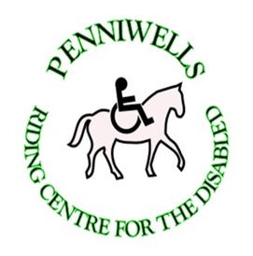Penniwells Pony Sponsorship
Would you like to join our much-valued team of pony sponsors at Penniwells RDA Centre?
Each pony costs in the region of £5000 every year to fund before any shoeing or vets bills
Penniwells is giving you the opportunity to help sponsor our ponies into the future - For only £30 you will receive a Certificate and Photograph of your favourite horse or pony at Penniwells RDA

Ponies available for sponsorship are:
Beauty, Ana, Sonny, Blue, Bertie, Dougal, Tayto, Baxter,
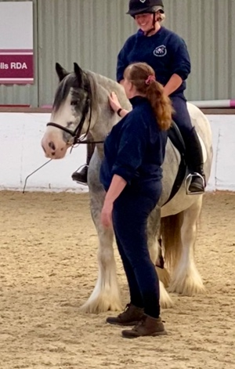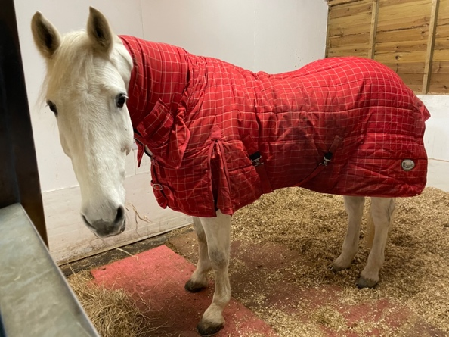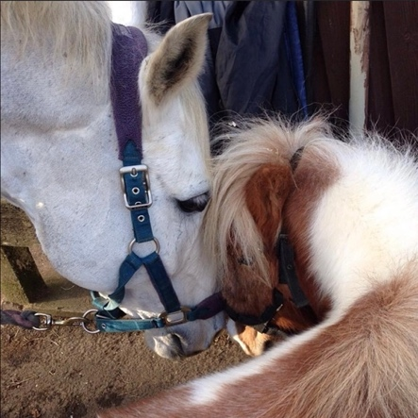

By sponsoring a Penniwells Horse or Pony you are directly helping to change the lives of our riders - Thank you
Pony Sponsorship Application Form
Name of Sponsor | Name of horse/pony | Age of Sponsor if under 18yrs | Are you a rider, volunteer or supporter? | Total Cost at £30 each

Please fill in all details below & send you application to:
Pony Sponsorship, Penniwells RDA Centre, Edgwarebury Lane, Elstree, Herts WD6 3RG
Email address:………………………………………………………………………………….
Mobile Number………………………………………………………………………………..
Cheques made payable to: Penniwells Riding Centre
Please Sign Gift Aid If you are a tax payer:
Please treat the enclosed gift of £________________ as a gift aid donation
.You must pay an amount of Income Tax and/or Capital Gains Tax in each tax year at least equal to the tax that the charity will claim from HMRC on your Gift Aid donations.
Sponor’s details Title______ Initial(s)__________ Surname_____________________
Home address_________________________________________________________
_____________________________________________________________________
Postcode___________________________________ Date______________________
Signature___________________________________
Please notify Penniwells if you:
- Want to cancel this gift aid declaration.
- Change your name or home address
- No longer pay sufficient tax on your income and/or capital gains.
Tax claimed by Penniwells
- Penniwells will reclaim 25p of tax on every £1 you give during the previous 4 years
If you pay income tax at the higher rate you must include all your Gift Aid donations on your Self Assessment tax return if you want to claim the additional tax relief due to you.

