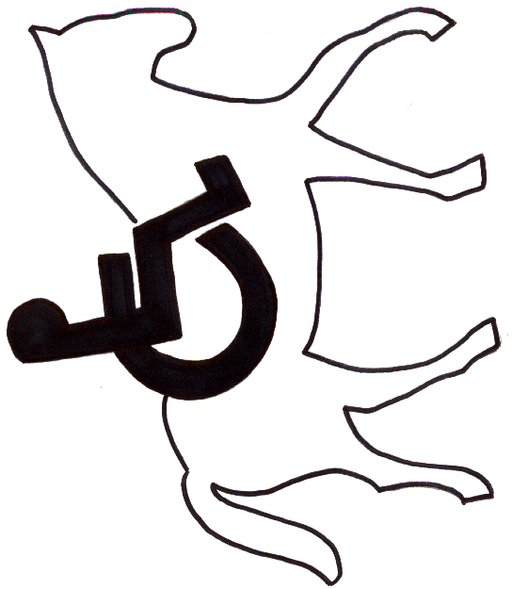
PENNIWELLS RIDING CENTRE
PENNIWELLS
Riding Centre for the Disabled
FOR THE DISABLED
Registered Charity No.1120263
Company Ltd by Guarantee 5010395
Penniwells Farm
Edgwarebury Lane
Elstree, Herts
WD6 3RG
Tel: 0208 207 4525
penniwellsrda@outlook.com
www.penniwellsrda.com

GIFT AID DECLARATION
PENNIWELLS RIDING CENTRE FOR THE DISABLED

Please treat

□ The enclosed gift of £________________ as a gift aid donation; OR

□ All gifts of money that I make today and in the future as gift aid donations; OR

□ All gifts of money that I have made in the past four years and all future gifts of money that I make from the date of this declaration as Gift Aid donations.

✓ Please tick the appropriate box

You must pay an amount of Income Tax and/or Capital Gains Tax in each tax year at least equal to the tax that the charity will claim from HMRC on your Gift Aid donations.

Donor’s details

Title______ Initial(s)_________________ Surname___________________________

Home address_________________________________________________________

_____________________________________________________________________

Postcode___________________________________ Date______________________

Signature___________________________________

Name of rider…………………………………………………….

Please notify Penniwells if you:
- Want to cancel this declaration.
- Change your name or home address
- No longer pay sufficient tax on your income and/or capital gains.

Tax claimed by Penniwells
- Penniwells will reclaim 25p of tax on every £1 you give during the previous 4 years

If you pay income tax at the higher rate you must include all your Gift Aid donations on your Self Assessment tax return if you want to claim the additional tax relief due to you.

Please keep this form signed and up to date if you plan to make Penniwells RDA a beneficiary in the future. Thank you.

