



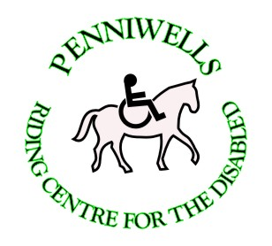
Penniwells RDA Centre
Edgwarebury Lane Elstree Herts WD6 3RG 0208 207 4525
Penniwells.rda@btconnect.com www.penniwellsrda.com
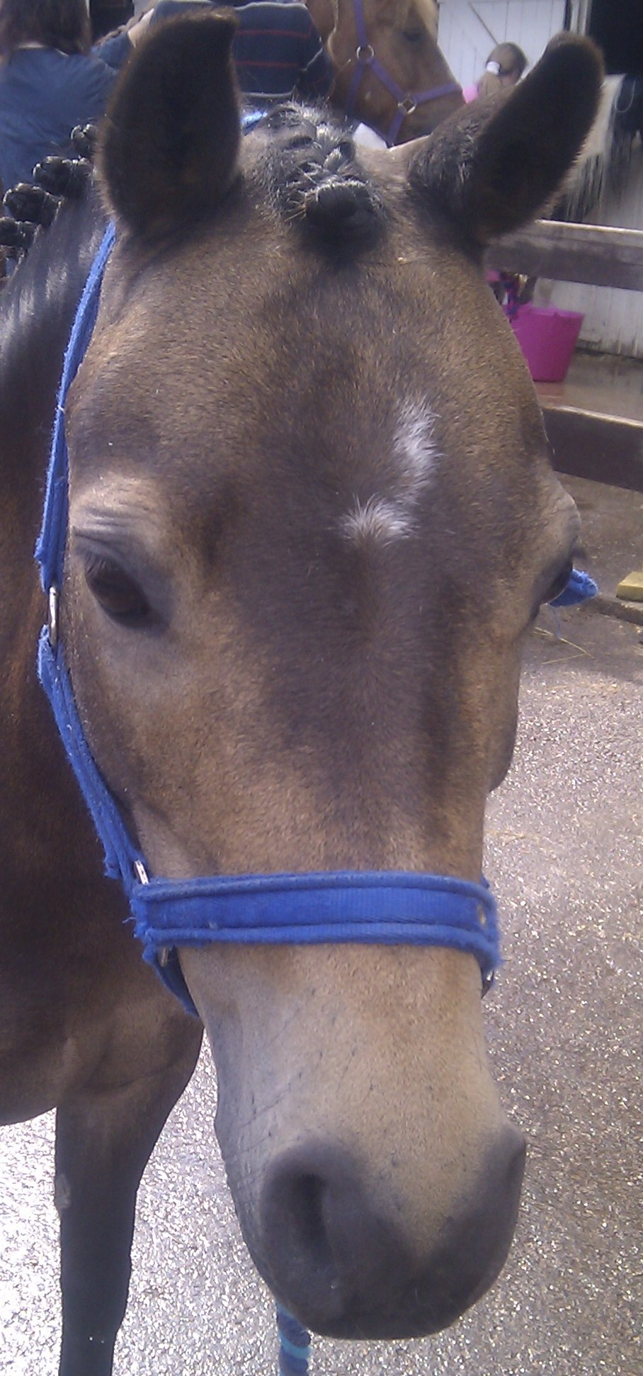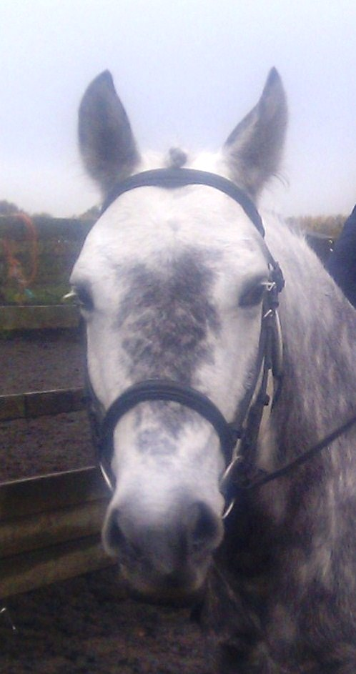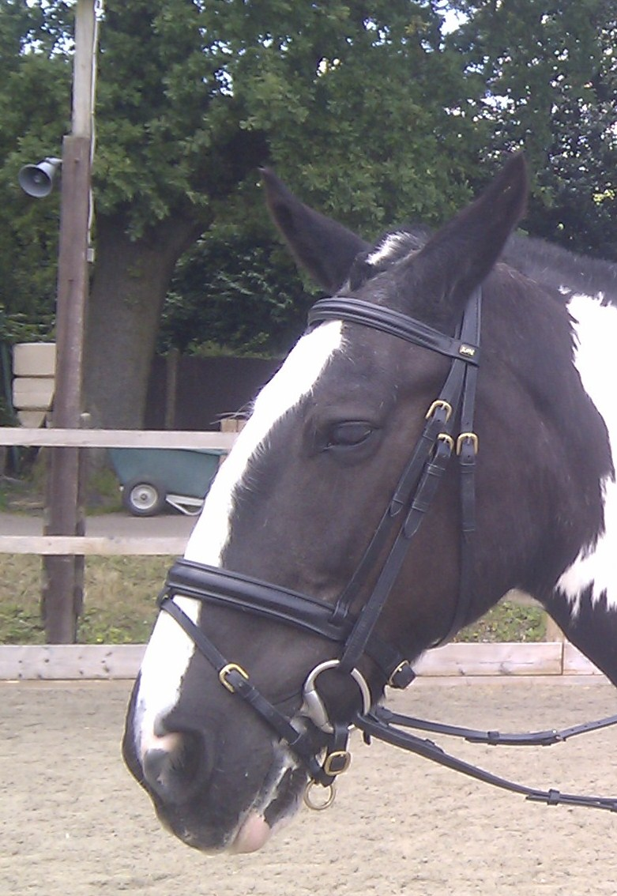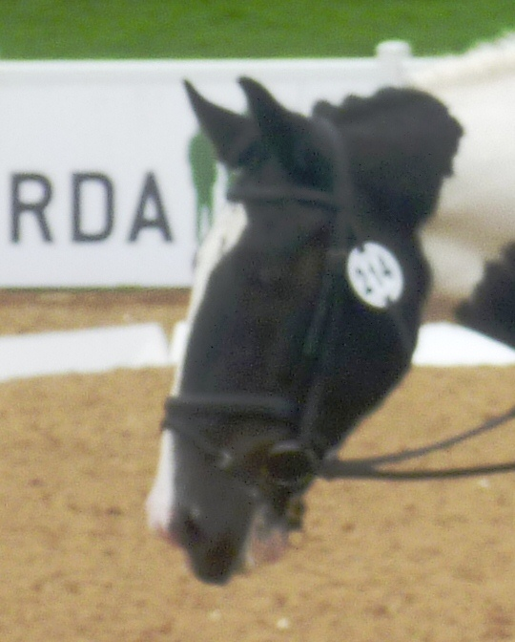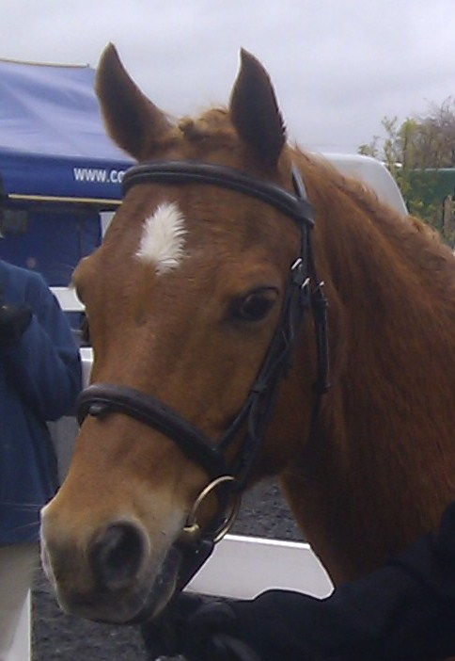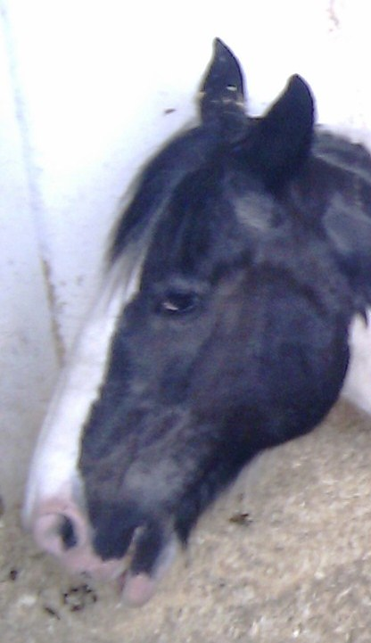
PENNIWELLS RIDING FOR DISABLED  CENTRE

Who we are
Penniwells Riding Centre for the Disabled is an independent registered charity. We attract riders & volunteers from within a 40 mile radius. Volunteers do anything from leading & side helping during ridden sessions to helping out with yard duties & general maintenance of the site.

What we do
We have provided therapeutic riding since 1980 for disabled children and adults in south Hertfordshire. 140 children and adults access riding lessons each week. Because riders have such a range of ability, we tailor goals to needs. Some start by grooming and talking to their pony. Some just learn to walk, others walk and trot, some walk, trot, canter and even jump and some progress to competitions at Regional, National & International level. We teach all riders to ride to the very best of their ability.

Reg charity 1120263

Dec 2015

PENNIWELLS CHARITY ABSEIL EVENT

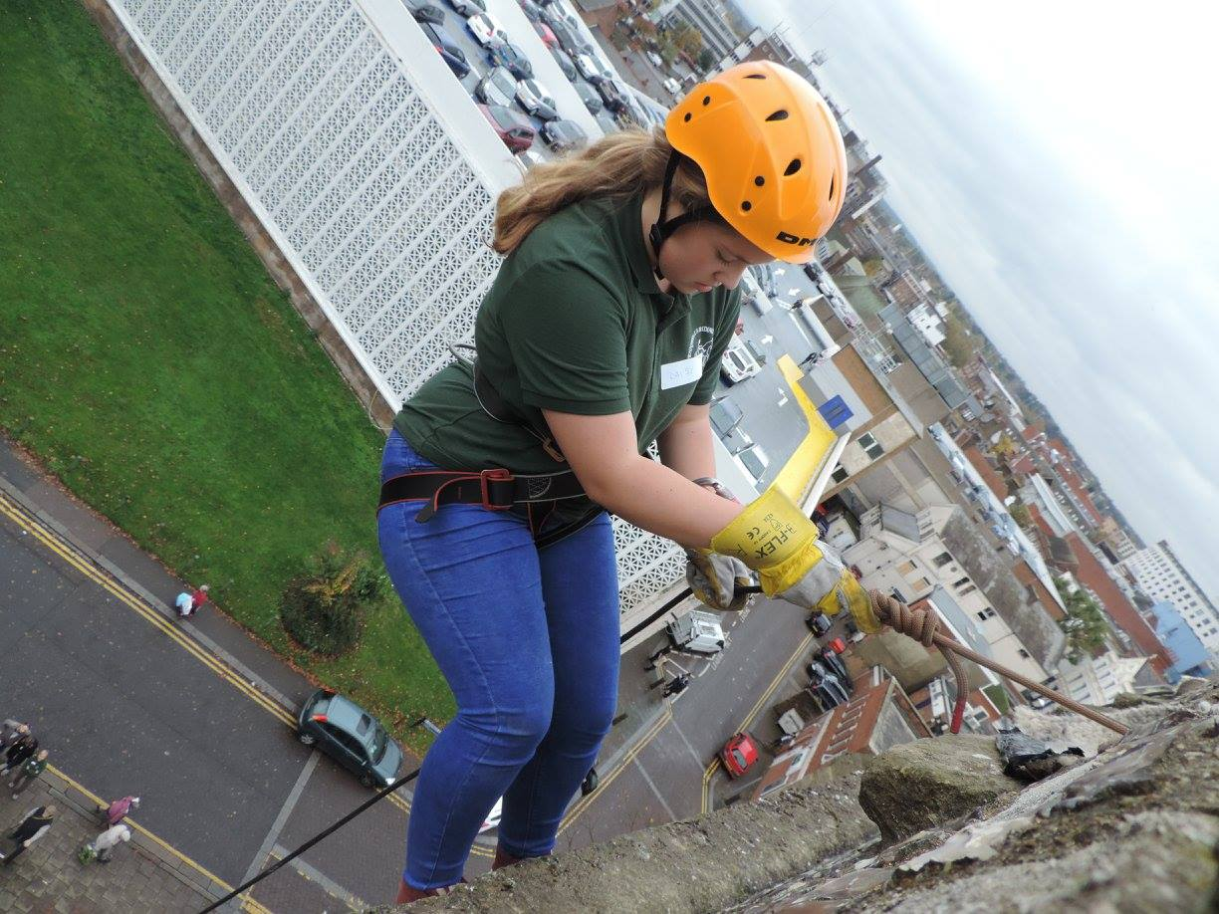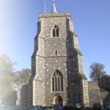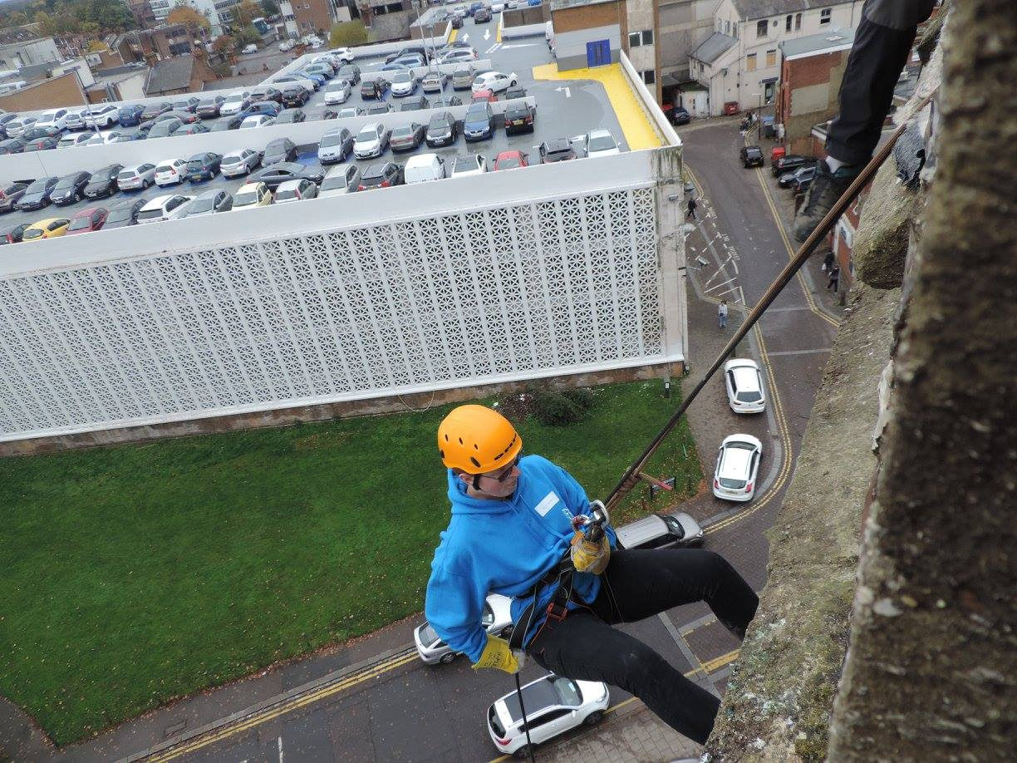

A huge well done to all our brave abseilers
23 riders, volunteers & supporters have raised over £7000

Dates for your diary in 2015:

Tuesday 22nd December – Volunteer training morning followed by Christmas Lunch at The Battleaxes

Penniwells will be closed for the Christmas Period from
21st December – 5th January



Returning to normal sessions on Wednesday 6th January 2016

Please keep an eye for notices in the classroom and on the website for more details – or come and ask us!

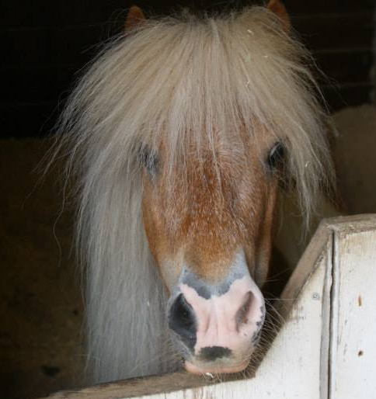
Chosen charity of the year by Cardif Pinnacle
WELL DONE TO REBECCA BROWN
ON PASSING THE RDA SILVER PROFICIENCY TEST
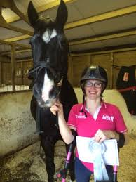
Rebecca is the first rider to achieve the Silver Award from Penniwells RDA

She also then took part in our abseil event
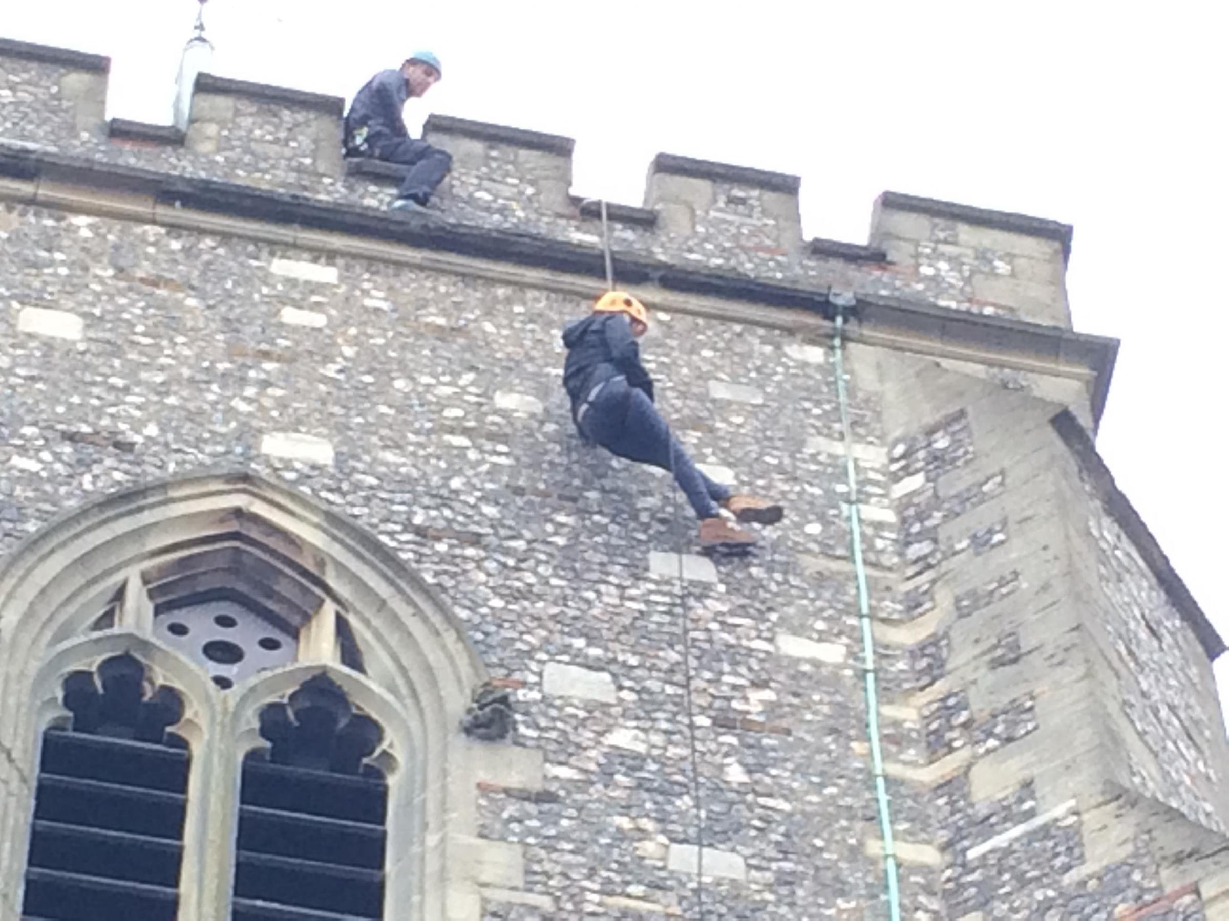

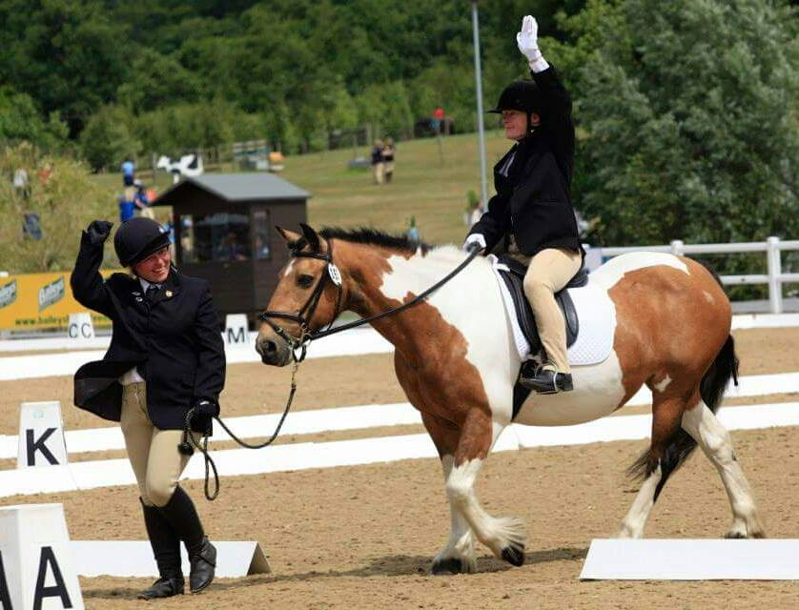

A MESSAGE FROM OUR CHAIRMAN
Thank you to everyone continuing to support Penniwells today.

The running of Penniwells is a costly business, with five full time staff, 14 horses and ponies, not to mention insurance and other running costs; the annual expenditure is over £160,000

We raise this money through riding fees, donations and fundraising events. This year has been yet another highly successful year at Penniwells.

I would like to encourage you to become a Friend of Penniwells (FOP) for only £15 per year and that you continue to be a successful, long lasting part of Penniwells.

We are always looking for new members to help us in our fundraising ventures so please ask if you would like to become more involved

I would like to wish you all very Merry Christmas and a Happy 2016

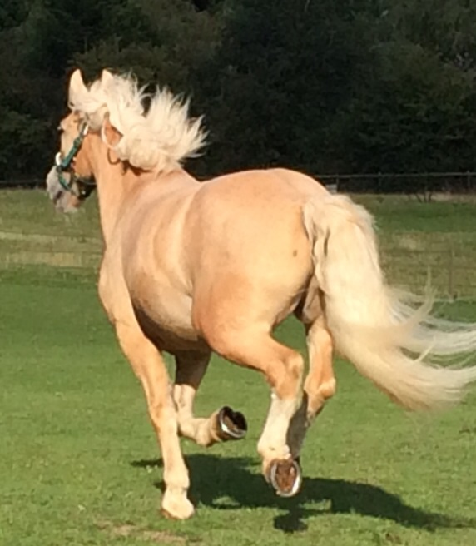
Thank you for supporting us.
Trix Summerfield, Chairman of Penniwells 0208 953 4109

PENNIWELLS RDA CENTRE


HOW CAN YOU HELP US??

PENNIWELLS RDA CENTRE FUNDRAISING SUGGESTIONS & PROCESS

REG CHARITY 1120263

COULD YOU?
- Pick Penniwells RDA as your Charity of the Year
- Organise a Jeans for Genes days
- Run a stall or table top sale
- Volunteer at The Centre on a regular basis – Minimum age 13yrs
- Hold a fund raising event
- Take part in Sponsored Walks, Swims, Treks, Marathons
- Join the Penniwells’ Fundraising Team to help organise events throughout the year
- Adopt or sponsor a pony
FACTS ABOUT PENNIWELLS FUNDS
- It costs more than £160,000 every year to run
- Only £60,000 is raised through riding fees
- £90,000 every year has to be raised through fund raising & donations
- We receive NO direct funding from the Government or RDA National Office
- Feeding the ponies costs £1500 every month
- Farrier costs £800 every 6 weeks
- Staff costs – without our qualified staff in place the first class service could not be provided
Volunteers we cannot do it without you!
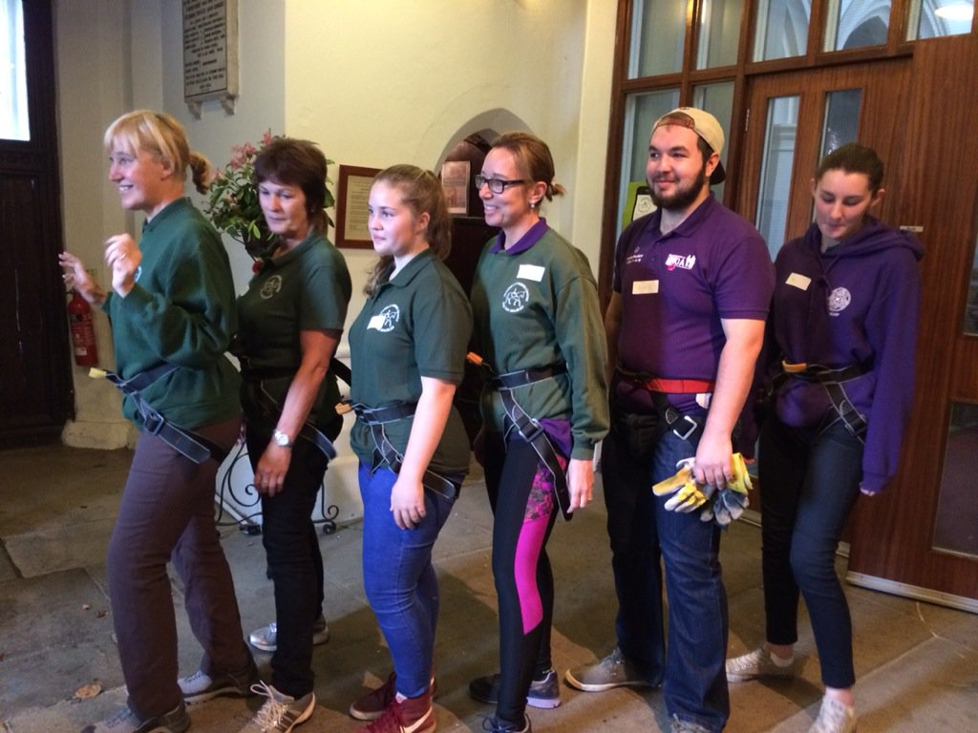


FRIENDS OF PENNIWELLS

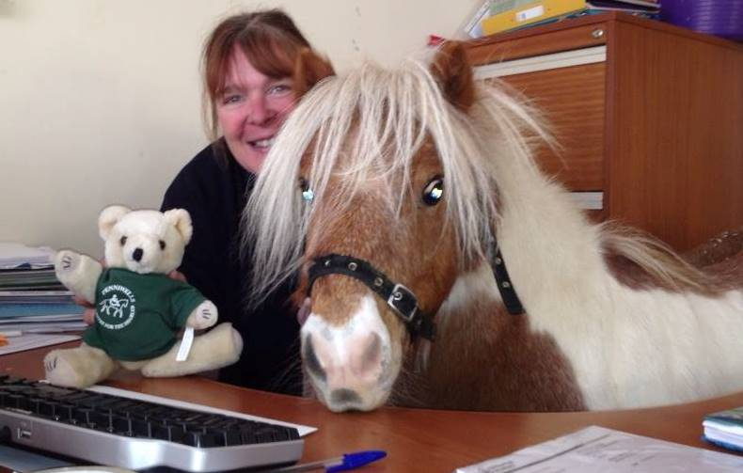
Please support Penniwells RDA by joining FOP – You will be kept up to date with the latest news, events & adventures! Anyone can join – Riders, volunteers & supporters for £15.00 per year

Prince is the National RDA
Horse of The Year 2015

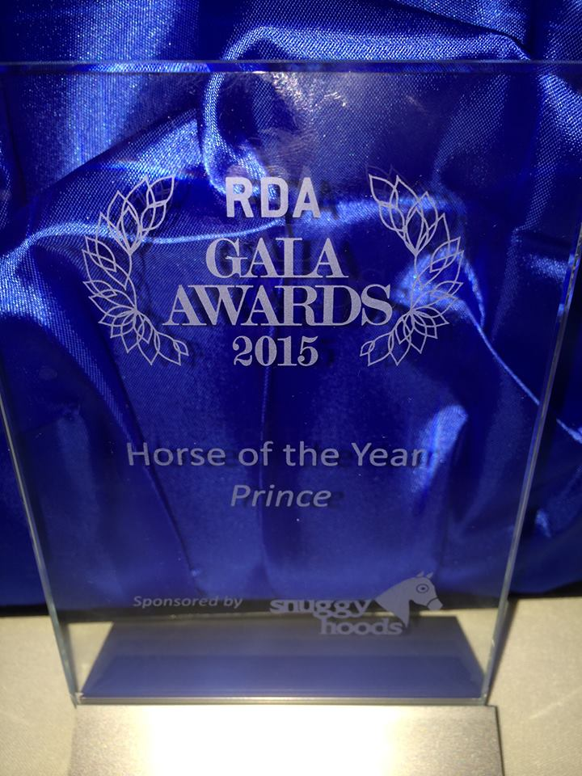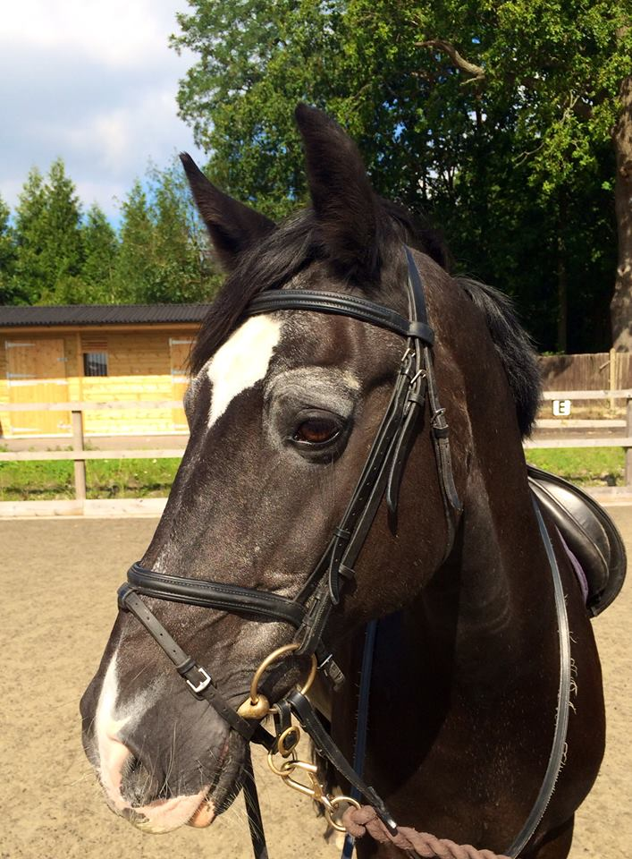

Well done to Prince and thank you to Rebecca brown & Sarah Healing for nominating him. He is a very special horse having given everything for RDA for 20 yrs. Thank you Prince!

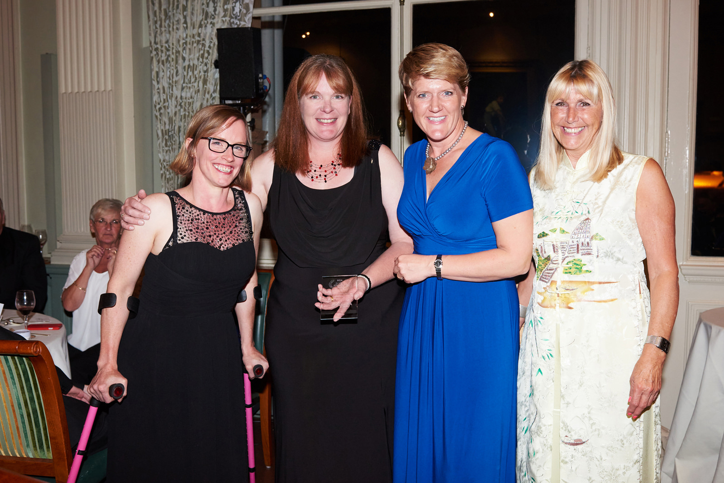

APPLICATION TO FRIENDS OF PENNIWELLS

NAME…………………………………………………………………..
ADDRESS………………………………………………………………
……………………………………………………………………………..
……………………………………..POST CODE…………………….
MOBILE……………………….HOME………………………….….
EMAIL…………………………………………………………………….
Annual membership enclosed £15.00
Paid by cheque, cash (Please circle)

DOB(IF UNDER 25YRS)………………………….

Are you a rider/volunteer/supporter? …………………………………………..

Would you like to be contacted about becoming more involved in Penniwells RDA?
YES or NO (Circle)

Gift Aid – If you are a tax payer and we can claim gift aid please sign

sign name………………………………………………………….

Print name ………………………………………

If you wish to make a donation and not be a member of FOPS please send your donations to:

FOA Chairman, Penniwells RDA Centre, Edgwarebury Lane, Elstree, Herts WD6 3RG

Donations can also be made online via Just Giving Penniwells RDA
Forms can also be found on the website or in the classroom
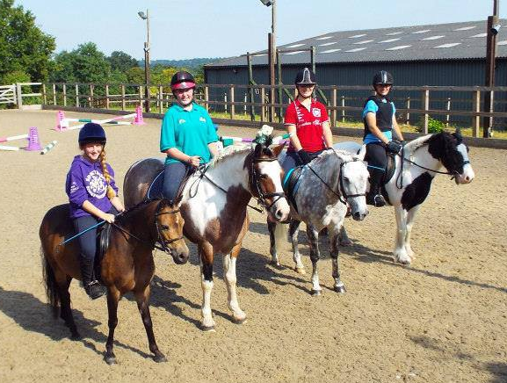
WHY VOLUNTEER?
Volunteering with Penniwells RDA is fun, rewarding and confidence building just to mention a few benefits. We couldn’t do what we do without Volunteers and to achieve more, we need even more help!

More than 18,000 volunteers throughout the UK give about 3.5 million hours of their time each year to further the aims of RDA. Could you become part of this amazing and dynamic team!

Penniwells is a Team where everyone involved has a role to play – we find peoples strengths and abilities as well as offering full training in those areas where they may have had less experience.
Penniwells is a very special & unique place touching the lives of so many different people.

VOLUNTEERING #changinglives 

The Staff Team are always looking to progress their knowledge & skills in order to pass on their skills to the riders & volunteers.
WELL DONE TO:
Sarah Healing – Passed RDA Senior Coaching

Sam Peck – Passed RDA Coaching

Emily Coombs – UKCC Level 2 final assessment coming up

Vanessa Andrews – NVQ level 3 underway

“You could be part of our Team succeeding in changing the lives of people forever!”

WHY NOT CONTACT US NOW TO JOIN:

Penniwells RDA
Edgwarebury Lane Elstree Herts WD6 3RG
www.penniwellsrda.com
0208 207 4525
Penniwells.rda@btconnect.com

