



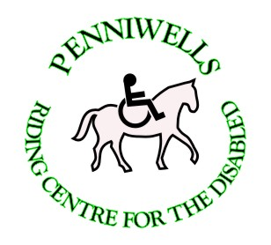
Penniwells RDA Centre
Edgwarebury Lane Elstree Herts WD6 3RG 0208 207 4525
Penniwells.rda@btconnect.com www.penniwellsrda.com
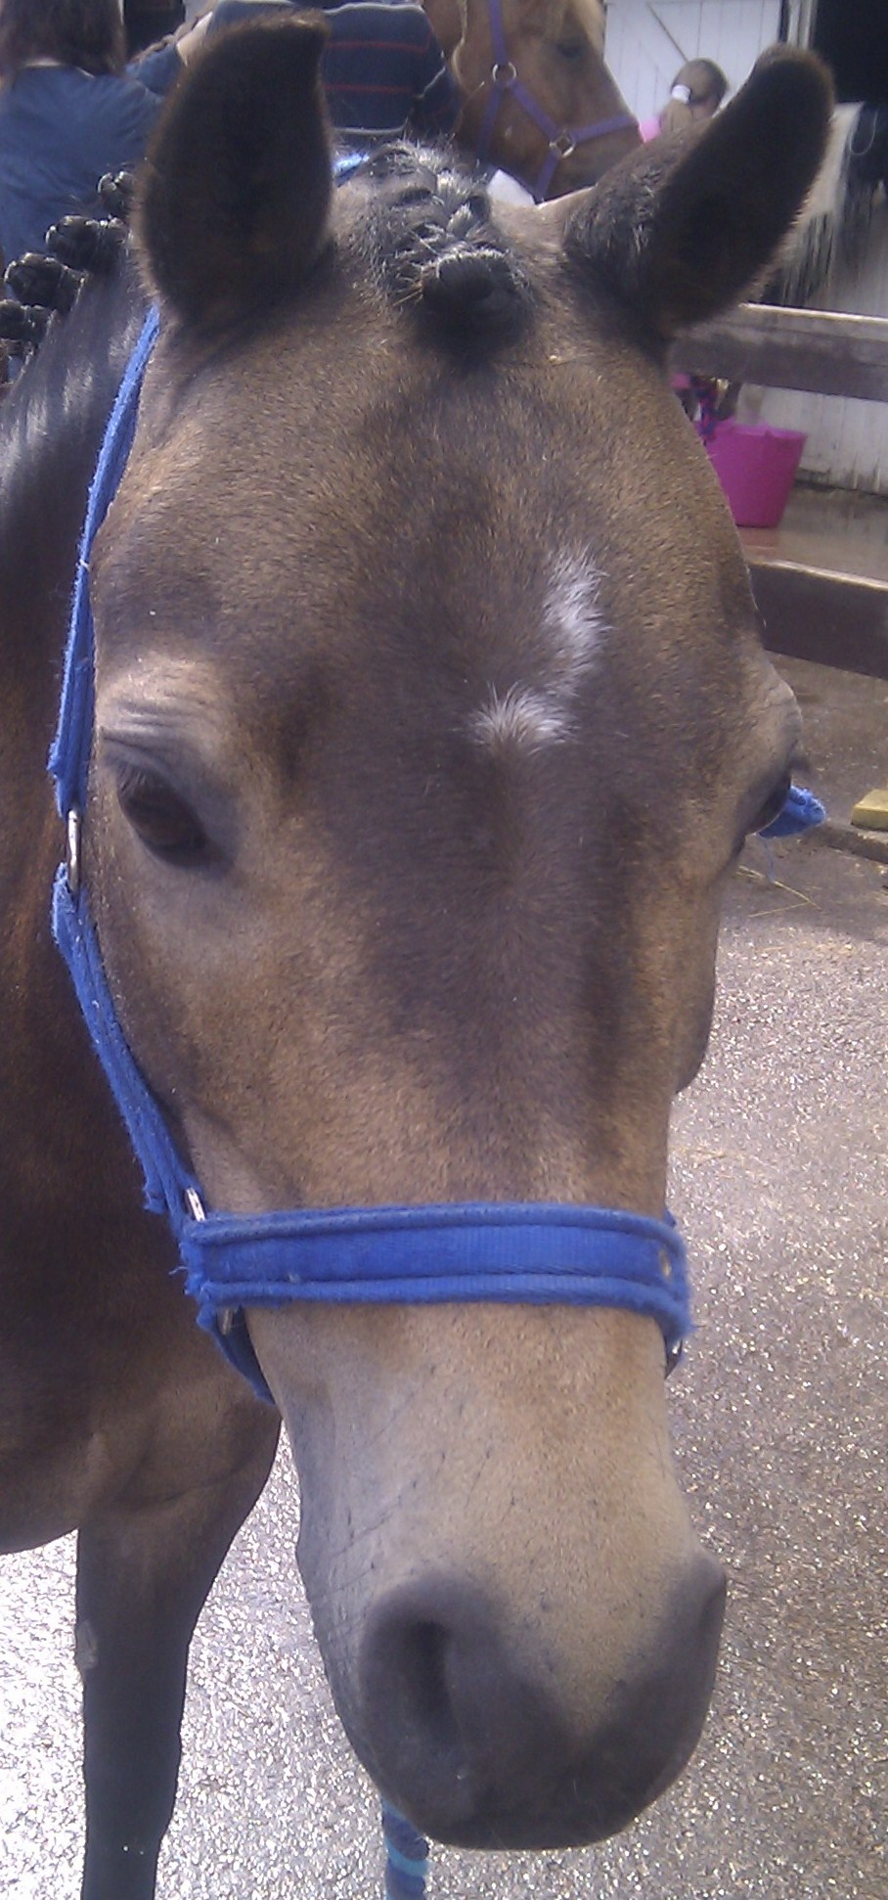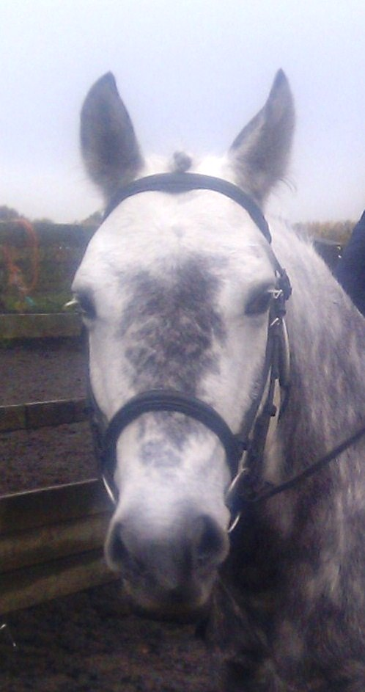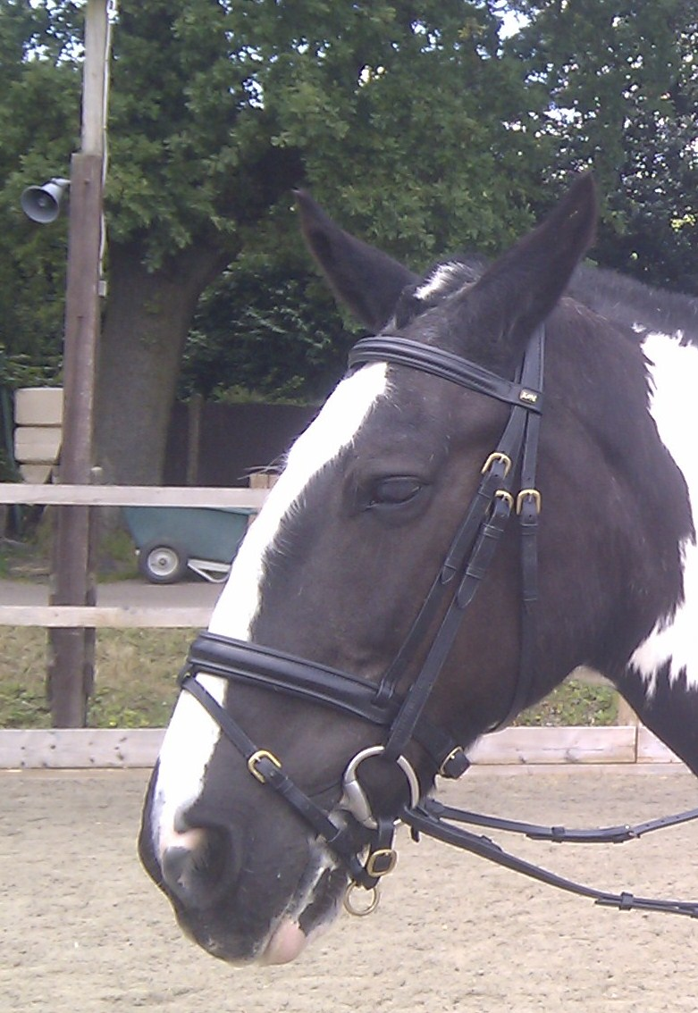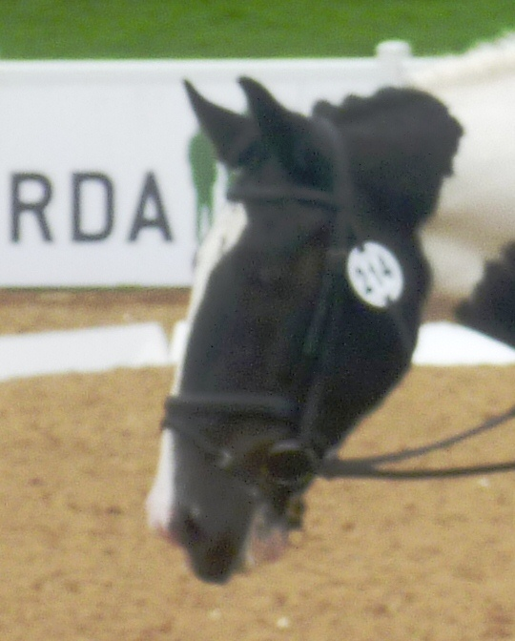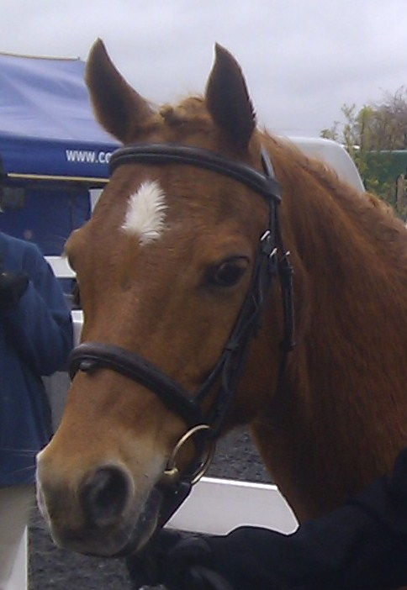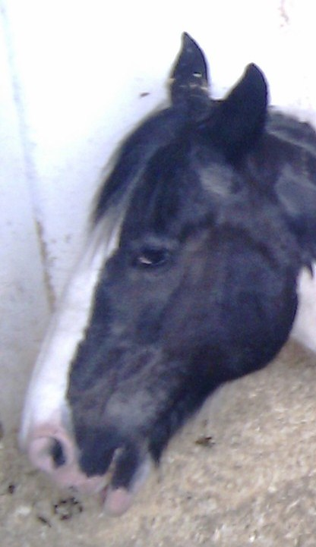
PENNIWELLS RIDING FOR DISABLED CENTRE

Who we are
Penniwells Riding Centre for the Disabled is an independent registered charity. We attract riders & volunteers from within a 40 mile radius. Volunteers do anything from leading & side helping during ridden sessions to helping out with yard duties & general maintenance of the site.

What we do
We have provided therapeutic riding since 1980 for disabled children and adults in south Hertfordshire. 140 children and adults access riding lessons each week. Because riders have such a range of ability, we tailor goals to needs. Some start by grooming and talking to their pony. Some just learn to walk, others walk and trot, some walk, trot, canter and even jump and some progress to competitions at Regional, National & International level. We teach all riders to ride to the very best of their ability.

REG CHARITY 1120263

April 2015

How Are We Funded
Penniwells receives no direct funding from central government and relies on the generosity of individuals, businesses and charitable trusts to run our Centre. Every year it costs us in the region £160,000 to undertake our activities. We are a highly progressive and ambitious Centre of Excellence.

You could donate straight to Penniwells from your mobile and make a difference right now:

Text: COCO 35 £10.00 To 70070

Dates for your diary in 2015:

- Saturday 11th April – Quiz night at Penniwells RDA
- Wednesday 27th May – Regional Event Qualifiers
- 4th & 5th June – UKCC L2 Course
- 16th – 19th July – RDA National Championships
- 30th September – RDA Gala Awards – get your nominations in for Penniwells!!
- 10th October – Penniwells Annual Ball
- October TBC Charity Abseil Day
- 5th December – Annual Awards 2pm start

Please keep an eye for notices in the classroom and on the website for more details – or come and ask us!

Thank You to our volunteers/parents for helping out
with providing refreshments and lunches

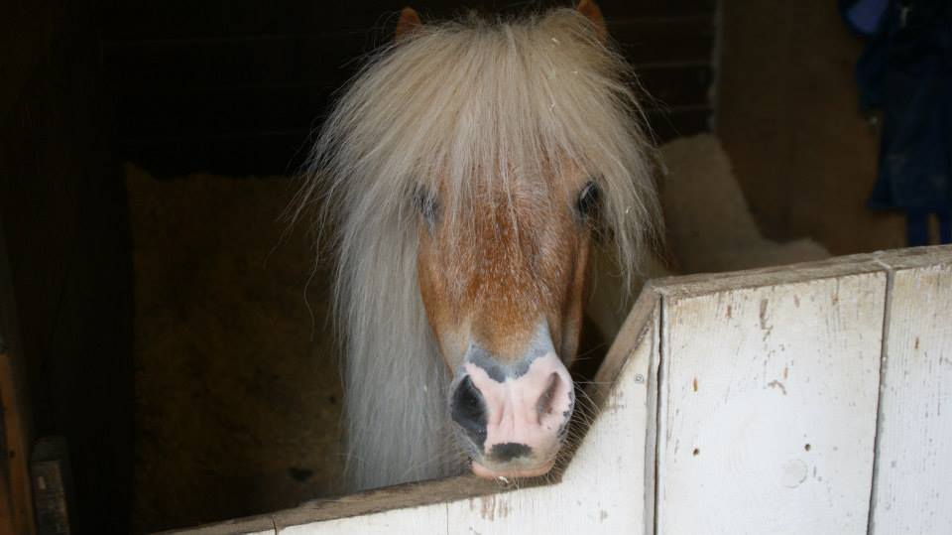
Chosen charity of the year by Cardif Pinnacle

PENNIWELLS SADDLE CLUB – You can apply to join at any time

- When does it run? Wednesday evenings 5.30pm – 7.30pm and Thursday 3.20pm – 5.20pm
- Who can join? Any existing rider already riding regularly at Penniwells
- Do you have to give up your weekly riding space to attend the club? The aim long term will be that the Saddle Club will replace your usual riding slot – This is to enable us to use the slots you move out of to undertake more assessments and to take on new riders therefore greatly reducing the waiting list
- How much will it cost? This term we will be asking for a donation of only £5 per week per rider
- How will it run? Each rider will be in an appropriate group and receive a 45mins riding sessions and 45mins stable management session. All will be encouraged to take the RDA tests
- How do you apply? An application is available at The Centre and on the Website
- Do parents/carers have to stay for the duration? This is assessed on an individual basis as we cannot provide personal care – Please ask when you apply
- Do you get refreshments? Yes and there will be time to socialise between sessions with other riders and volunteers
- What are the benefits? Opportunity to increase their skills and knowledge both on & off the pony
- New Volunteers are needed for this session – Please apply!
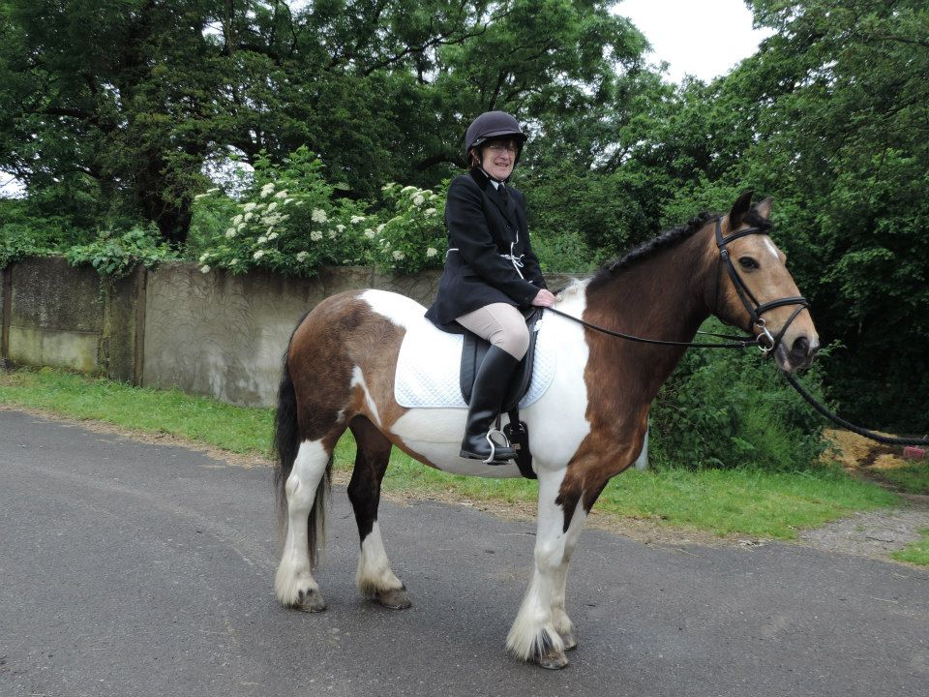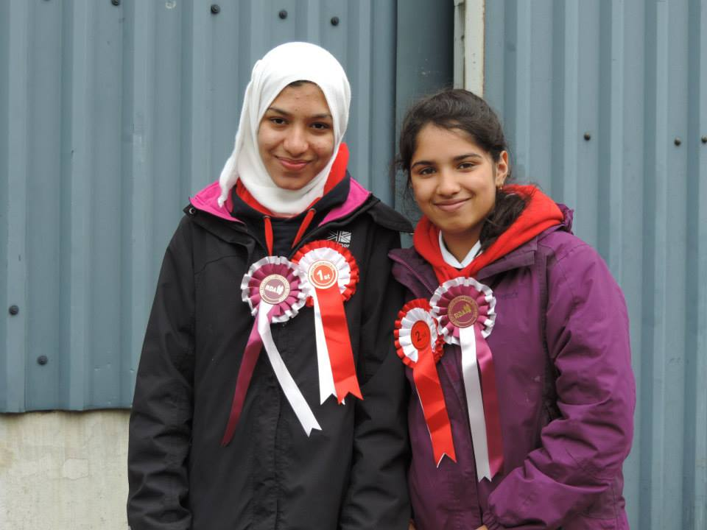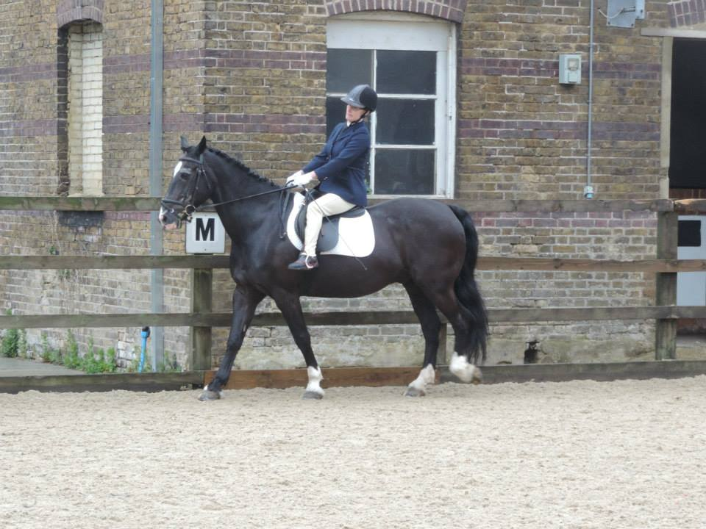

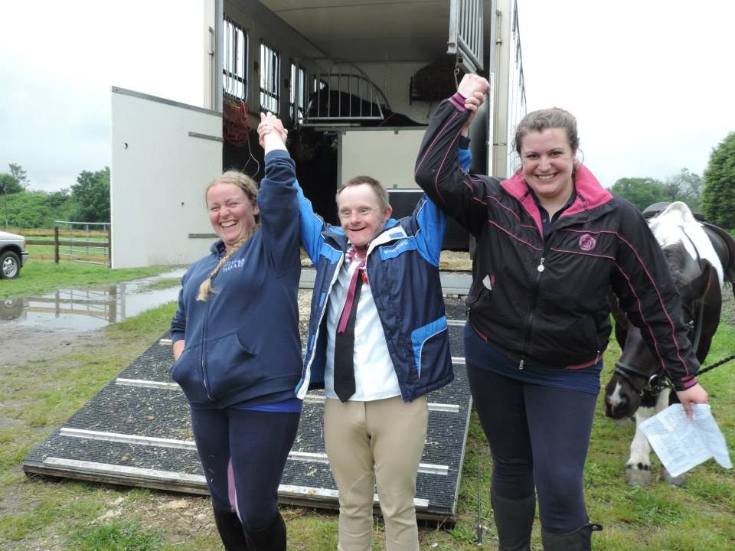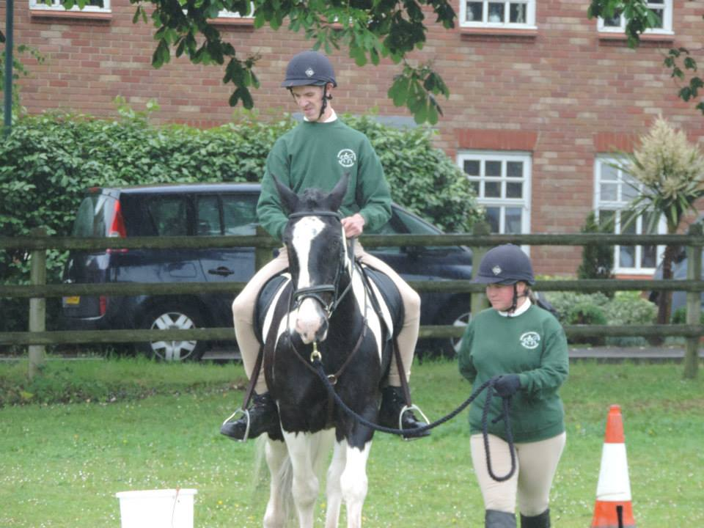

A MESSAGE FROM OUR CHAIRMAN

Thank you to everyone continuing to support Penniwells today.

The running of Penniwells is a costly business, with five full time staff, 14 horses and ponies, not to mention insurance and other running costs; the annual expenditure is over £160,000 We raise this money through riding fees, donations and fundraising events. This year has been yet another highly successful year at Penniwells.

I would like to encourage you to become a Friend of Penniwells (FOP) for only £15 per year and that you continue to be a successful, long lasting part of Penniwells.

We are always looking for new members to help us in our fundraising ventures so please ask if you would like to become more involved.

Thank you for supporting us.
Trix Summerfield, Chairman of Penniwells 0208 953 4109
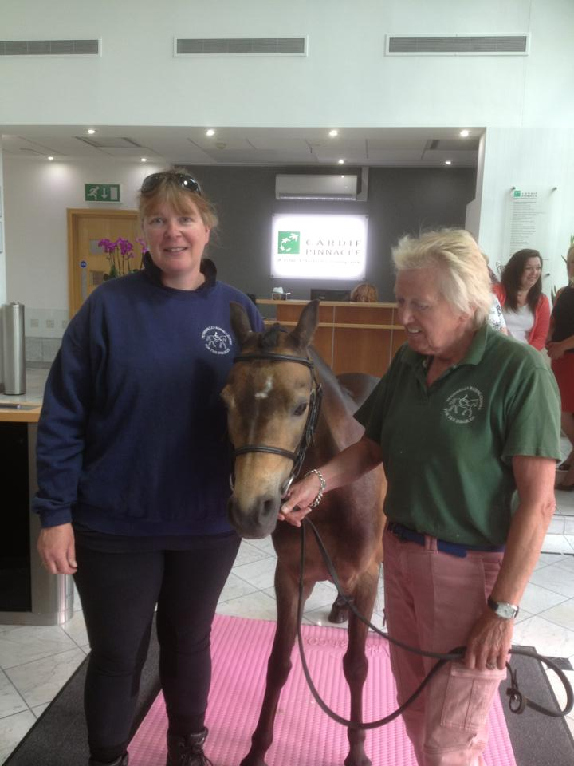
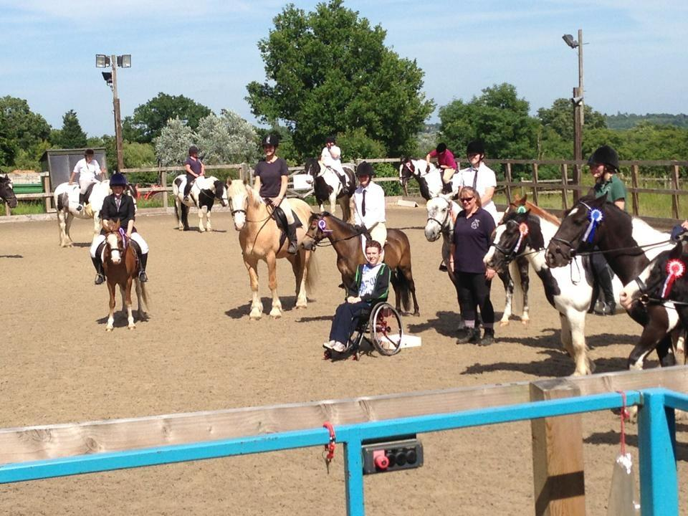
PENNIWELLS RDA CENTRE


HOW CAN YOU HELP US??

PENNIWELLS RDA CENTRE FUNDRAISING SUGGESTIONS & PROCESS

REG CHARITY 1120263

COULD YOU?
- Pick Penniwells RDA as your Charity of the Year
- Organise a Jeans for Genes days
- Run a stall or table top sale
- Volunteer at The Centre on a regular basis – Minimum age 13yrs
- Hold a fund raising event
- Take part in Sponsored Walks, Swims, Treks, Marathons
- Join the Penniwells’ Fundraising Team to help organise events throughout the year
- Adopt or sponsor a pony
FACTS ABOUT PENNIWELLS FUNDS
- It costs more than £160,000 every year to run
- Only £60,000 is raised through riding fees
- £90,000 every year has to be raised through fund raising & donations
- We receive NO direct funding from the Government or RDA National Office
- Feeding the ponies costs £1500 every month
- Farrier costs £800 every 6 weeks
- Staff costs – without our qualified staff in place the first class service could not be provided
WHAT WILL WE DO?
- Visit you with a talk/power point where you can find out more about Penniwells RDA
- Help you set up a page on our Just Giving Site
- Allocate your project with a “Text to Donate” facility
- Help to spread the word about your project
- Send you details of all future Penniwells’ events
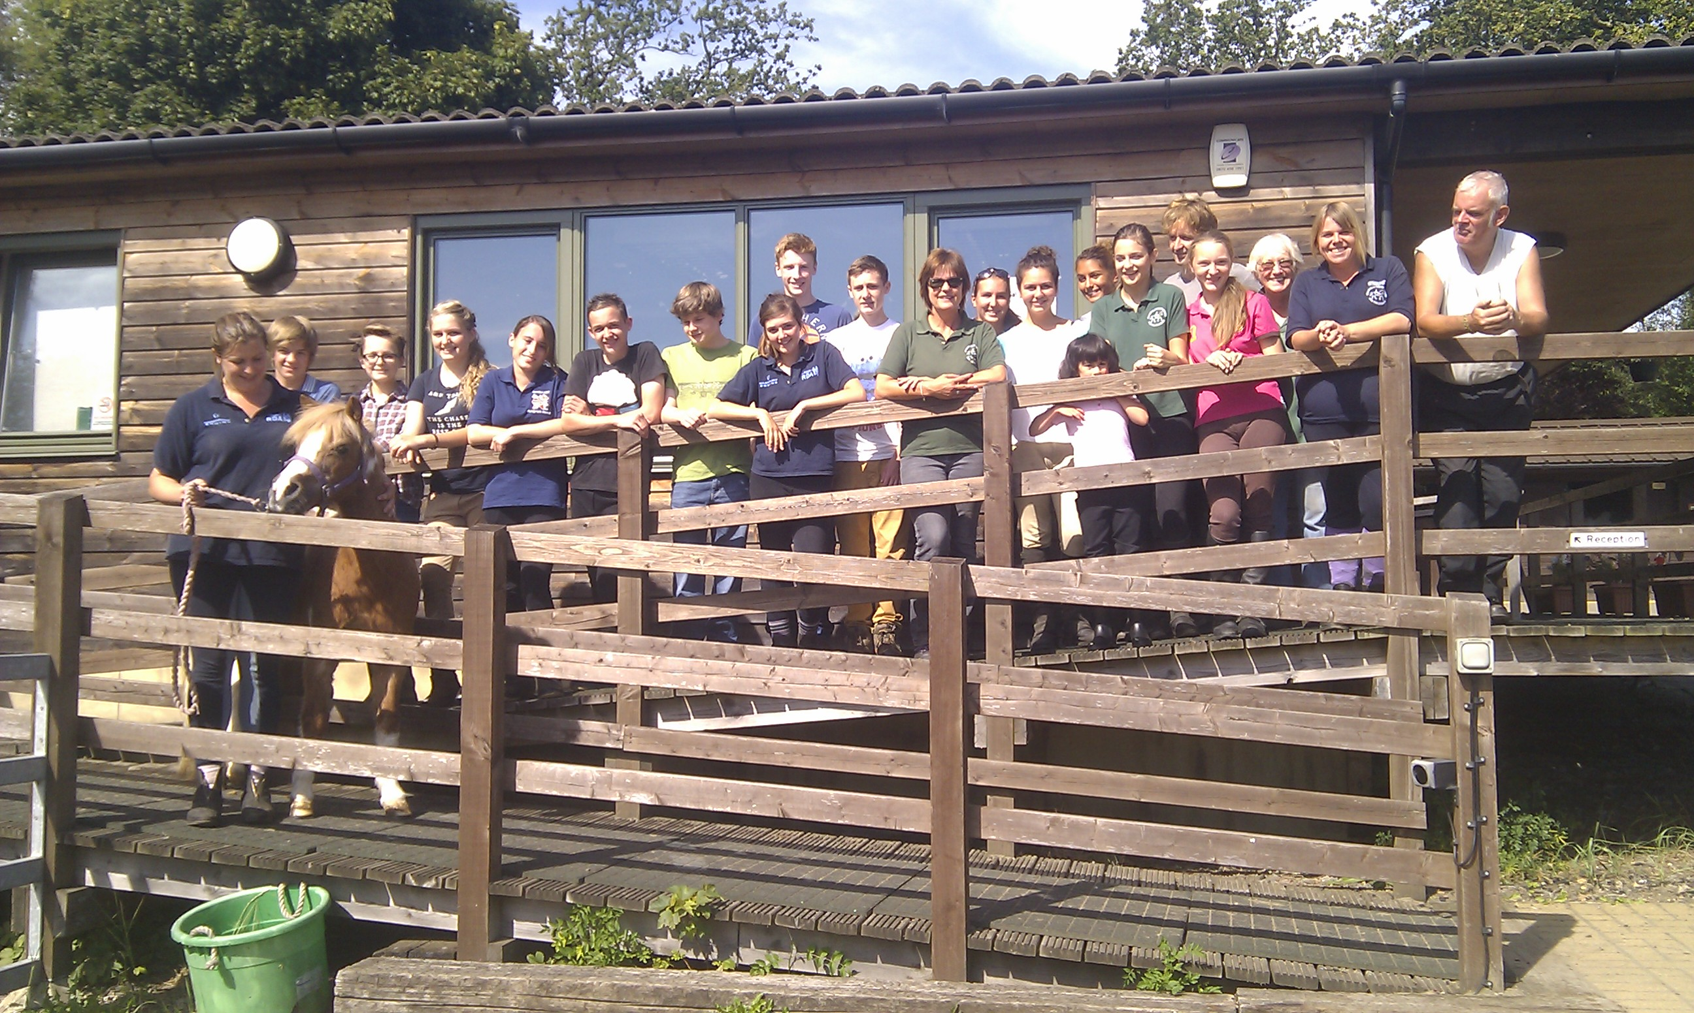

FRIENDS OF PENNIWELLS

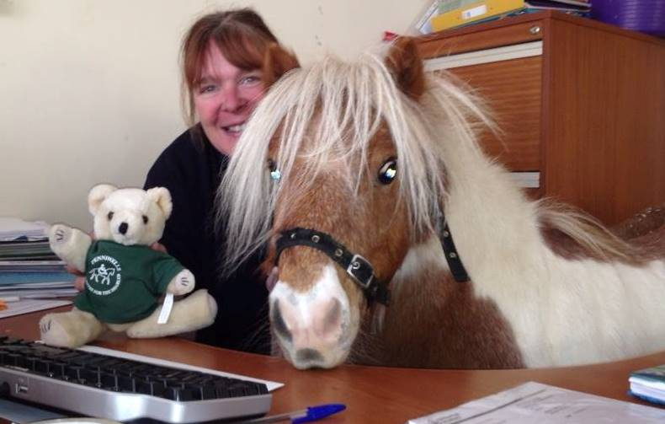
Please support Penniwells RDA by joining FOP – You will be kept up to date with the latest news, events & adventures! Anyone can join – Riders, volunteers & supporters for £15.00 per year
WE REALLY NEED YOUR HELP AT PENNIWELLS RDA CENTRE

PLEASE CONTACT US AT

penniwells.rda@btconnect.com

OR
Trix Summerfield 0208 9534109

Events coming up:

October half term we are arranging a CHARITY ABSEIL EVENT – if you are interested in taking part to raise funds for Penniwells RDA please get in touch asap
penniwells.rda@btconnect.com



APPLICATION TO FRIENDS OF PENNIWELLS

NAME…………………………………………………………………..
ADDRESS………………………………………………………………
……………………………………………………………………………..
……………………………………..POST CODE…………………….
MOBILE……………………….HOME………………………….….
EMAIL…………………………………………………………………….
Annual membership enclosed £15.00
Paid by cheque, cash (Please circle)

DOB(IF UNDER 25YRS)………………………….

Are you a rider/volunteer/supporter? …………………………………………..

Would you like to be contacted about becoming more involved in Penniwells RDA?
YES or NO (Circle)

Gift Aid – If you are a tax payer and we can claim gift aid please sign

sign name………………………………………………………….

Print name ………………………………………

If you wish to make a donation and not be a member of FOPS please send your donations to:

FOA Chairman, Penniwells RDA Centre, Edgwarebury Lane, Elstree,Herts WD6 3RG

Donations can also be made online via Just Giving Penniwells RDA
Forms can also be found on the website or in the classroom
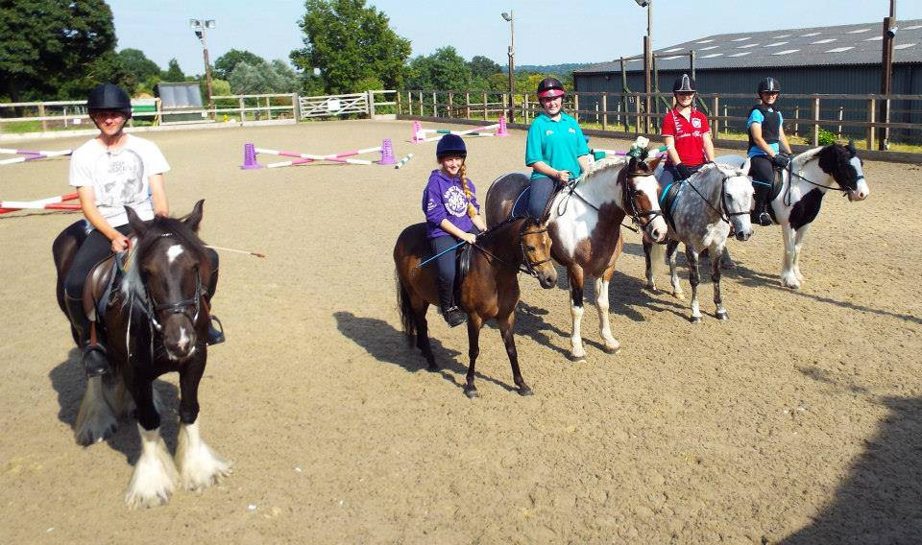
WHY VOLUNTEER?
Volunteering with Penniwells RDA is fun, rewarding and confidence building just to mention a few benefits. We couldn’t do what we do without Volunteers and to achieve more, we need even more help!

More than 18,000 volunteers throughout the UK give about 3.5 million hours of their time each year to further the aims of RDA. Could you become part of this amazing and dynamic team!

Penniwells is a Team where everyone involved has a role to play – we find peoples strengths and abilities as well as offering full training in those areas where they may have had less experience.
Penniwells is a very special & unique place touching the lives of so many different people.

VOLUNTEERING #changinglives

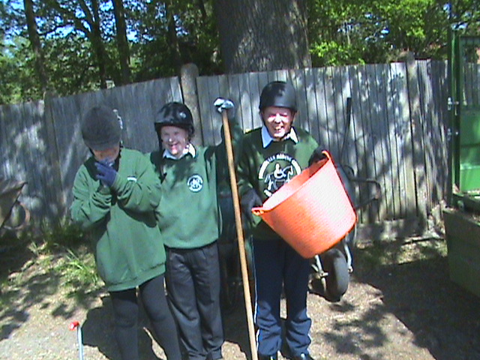

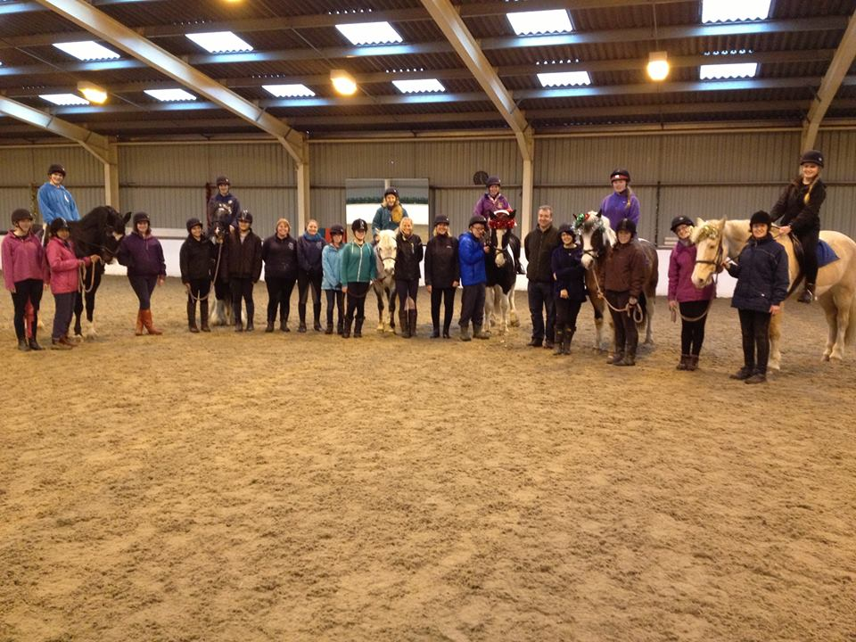
“You could be part of our Team succeeding in changing the lives of people forever!”

WHY NOT CONTACT US NOW TO JOIN:

Penniwells RDA
Edgwarebury Lane Elstree Herts WD6 3RG
www.penniwellsrda.com
0208 207 4525
Penniwells.rda@btconnect.com

