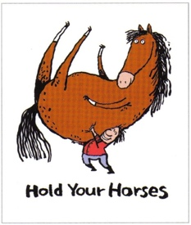

“Hold Your Horses”
Whilst our main aim is to offer a riding experience to our clients, we recognise that horse riding is not appropriate for everyone. As a result, we have been exploring how we could offer a stimulating and engaging non-riding experience. We have developed an experience, that can include one of or a mix of the following activities:
- Pony – see, touch, smell, hear – grooming
- Feed (explore feeding & hay) – see, touch, smell
- Stable (empty) – see, smell, hear – Water and bedding
- Tack (saddle/bits) – see, smell, touch – clean
- Mechanical horse – movement with Eddie
- Explore the fields and find different plants, grasses and spot animals & birds
- Walk & Talk - lead a pony around the tracks, for all with or without a wheelchair (although this may be weather dependent)
HOW DOES IT WORK?
- There will be a limited number of sessions available that must be booked and paid for in advance
- If you cancel with less than 24hrs notice you will be charged the full price unless your space is filled
- A maximum of 2 sessions can be booked
- Places need to be booked over the phone and paid for by Bank Transfer on the day of booking. You will be asked about your choice of activity when you book.
- Timeslots will be given on a Wednesday only to begin with as we run as a pilot project to gage interest – Slots will be available between 5pm and 7pm only
- Cost £20 for 20mins sessions to be paid at time of booking
- If you are new to the centre a participant form must be completed before booking

Call 0208 207 4525 now to book your place!

